Complex Web Page

ICAWEB502A & ICAWEB505A

Nolan Ryan

2014

Table of Contents

Task 1 2

Task 2 3

Task 3 3

# Task 1

This is a brief report on how the requirements for the website such as paragraphs, navigation, image maps and layout are achieved. For folder the structure I used folders such as css, images, js and php and for naming convention I used lowercase, no spaces and for Hypertext Mark-up Language files I used .htm.  
  
Folder Layout  
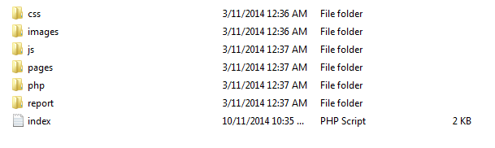

Site Layout  
The layout was achieved by using division tag and giving them specific names such as wrapper, headerwrapper, leftheader, rightheader, navbar, contentwrapper, mainbar, sidebar and footer. Then gave them specific settings in the css.  
  
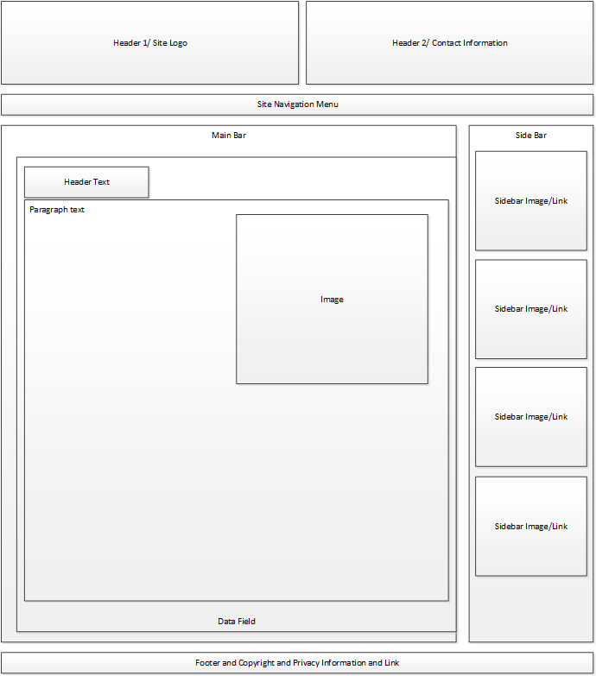

# Task 2

For Paragraph I added the settings to set the font to Verdana, Arial, Helvetica or sans-serif. I set the font size to 12px and the colour to black.

For Header1 I set the font to Verdana, Arial, Helvetica or sans-serif and set the font size to 24px. For letter spacing I set it to -2px and set the font colour to #b40c00. I set the font to be Bold and underlined. For Header 2 I did the same as Header 1 except for the font size was 20px and I did not use underline. For Header 3 same again except with smaller font at 16px different colour #e86600 and font style italic.

For navigation I used tables and anchors and was able to achieve look I desired. This was achieved by using table and placing anchors in a standard cell and for each second cell I would use a | to get nice spacing. And in the CSS I placed setup font to the usual ones and set the height to 30px as required and set width to 100% to make it fill the screen. For the anchors I used a class option to lets me select different colour and options for them.

The layout was achieved by using division tag and giving them specific names such as wrapper, header and navbar each div would have settings for each one such as height, width, padding and margin. For my site I used a wrapper and in the wrapper I have a header that contains right and left headers for the company logo and contact information. In my navbar it contains the links for all the html pages. For my main content and sidebar I placed them in a content container so I can control their heights. And lastly I placed my footer outside the wrapper after have a lot of problems with it.  
  
For the image map i was able to create image maps using division tab, image, unordered list, anchors and span tag. By loading the image I wanted into an img tag in the division tab and putting the unordered list’s <li> on a specific part of the division tab (i.e. top: 60% and left 20%) and whenever the mouse hovers over it would show the span’s text in tool tip.

# Task 3

I tested the website on Chrome, Firefox, Safari and Internet Explorer and all worked well.

Chrome:  
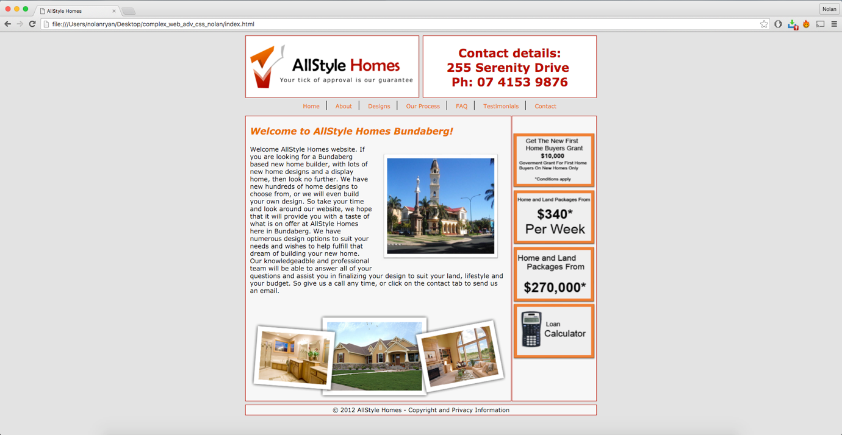

Firefox:  
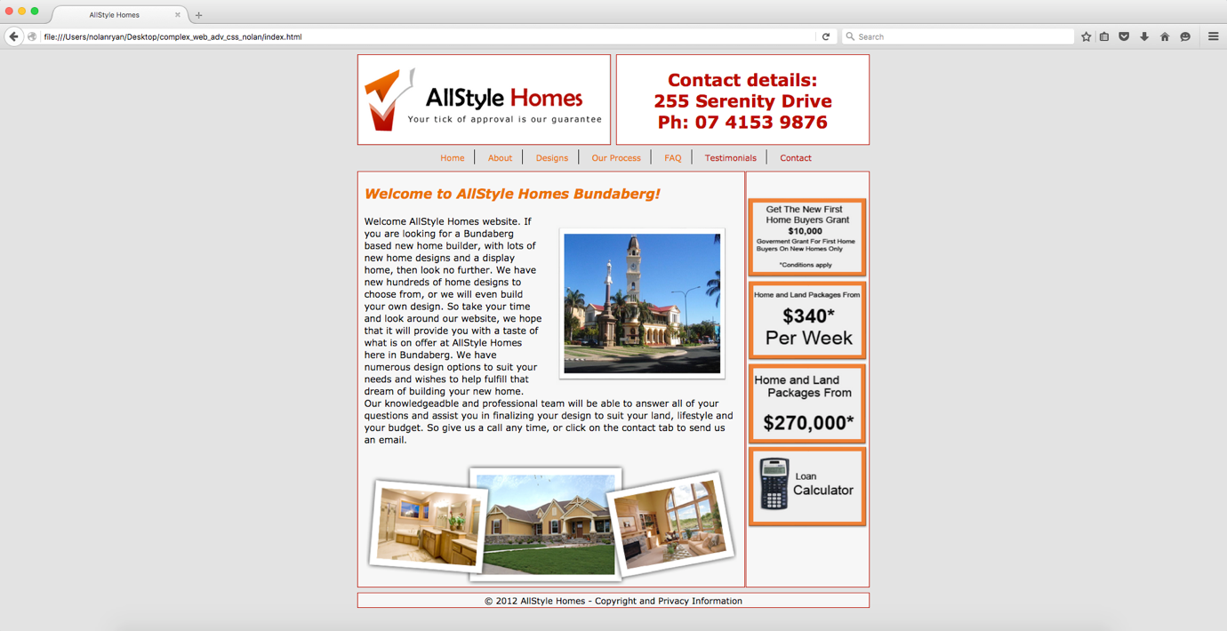

Safari:  
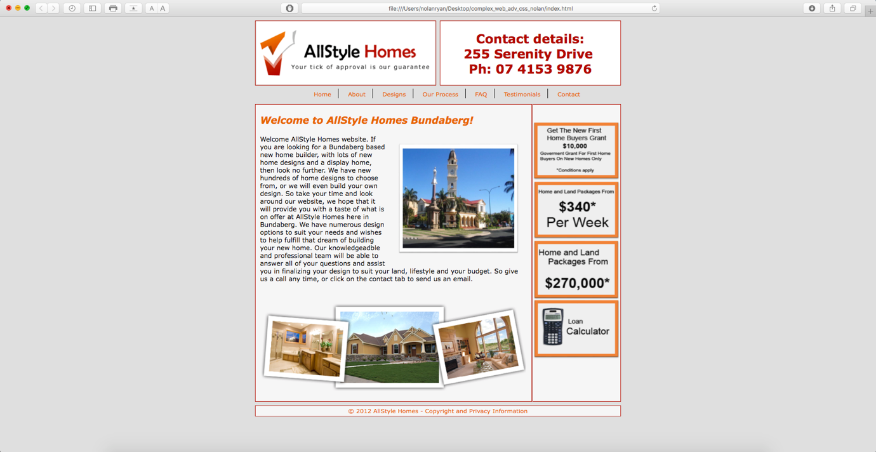

Internet Explorer:

I was able to successfully validate all my pages and css.

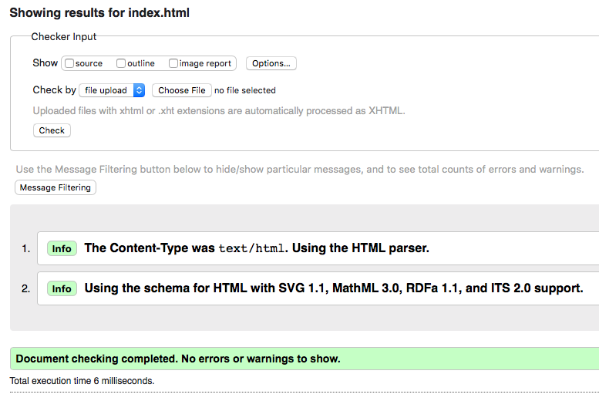

I have been getting CSS errors but from what I was able to find out online it could be a bug in the validator.

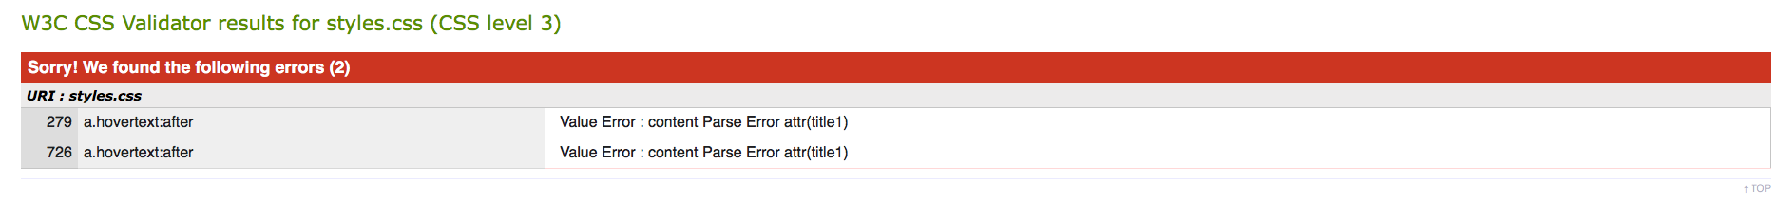

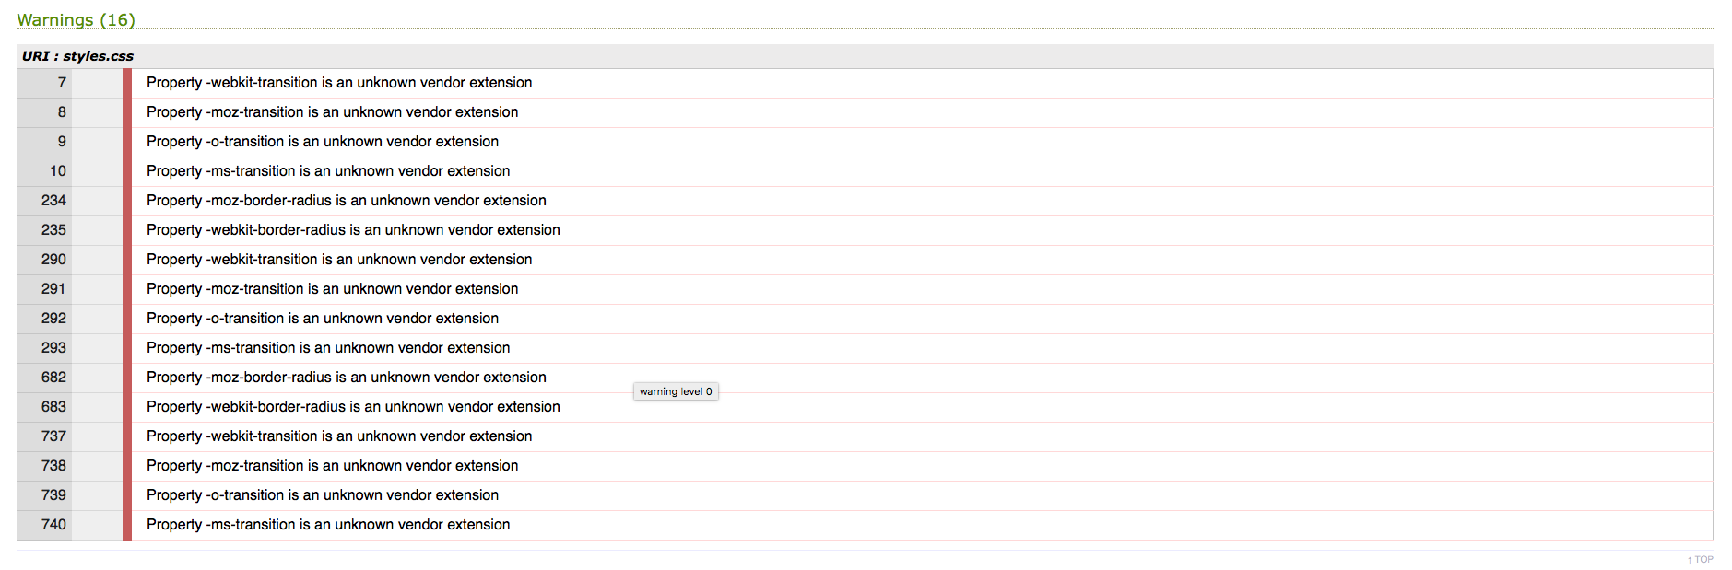

## Issues with website

I had a few minor issues with the website such as:

1. mailto link causing validate errors
2. fitting site on to small iPhone 4 and 5 screens

## Check List

1. Site works on all browsers – Yes
2. Does the site meet the technical specification criteria – Yes
3. Does the site meet the style guide criteria – Yes
4. Validate the site and css – Yes
5. Test site for accessibility standards – Yes
6. Identify any issues and fix them – Yes
7. Re-test site - Yes

## Recommendations and rectifications to issues

I was able to fix the mailto error by using Unicode to replace certain symbols such as for = with &#61;. For iPhone landscape was different from Samsung Galaxy S4 because instead of the normal reverse when going from portrait to landscape (i.e. portrait 400 height and 200 width to landscape 400 width and 200 height) the iPhone would keep the same height and width for both landscape and portrait but use the code landscape.

# Part 2

## Task 1

I was able to organize access to a web server at [www.fixated84.net/tafe_101_1](http://www.fixated84.net/tafe_101_1)

Here is the ping screenshot.

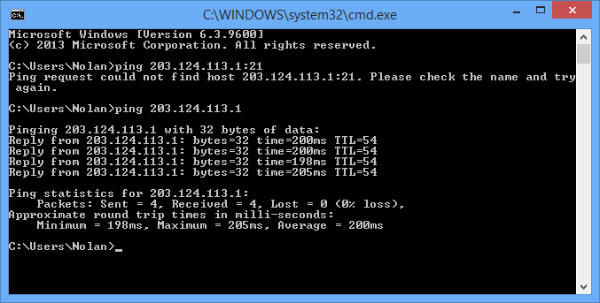

This is a screenshot of the test page loaded onto the server.  
  
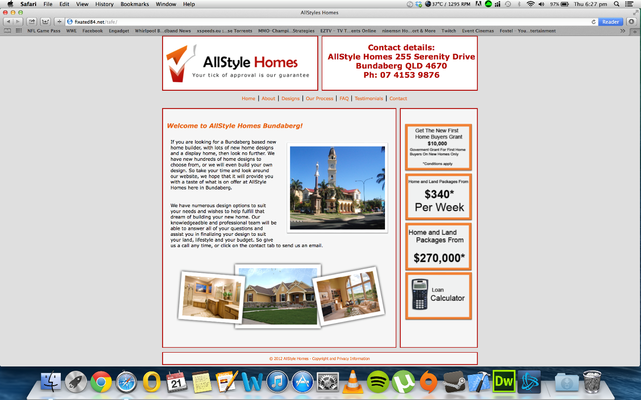

## Task 2

The hardware used in the development environment was a Metabox laptop and a MacBook Pro with an Asus monitor and razer keyboard and mouse. The software used was Windows 8.1, Mac OSX 10.9 and ftp client FileZilla. Dreamweaver and notepad++ was used to edit the html and css files. To test the websites for mobile I used a Samsung Galaxy S4 and Xcode on Mac OSX to emulate iPhones with 3.5inch and 4inch screens. The site administrator will only have access to the website because they are the only one with the knowledge to upload and change files correctly and login information.

I proposed a file system that is used in task 1 where folders such as pages, css, images, js and php.



## Task 3

The dynamic content I used on my pages is listed below.  
  
On the index page I used a welcome message based on the time of day. This script displays a welcome message based on the time of day the message will say good morning or good afternoon depending on what the time is.

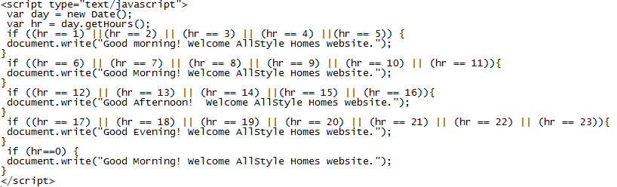

On the designs page I used an image gallery script. This script lists 14 images in boxes and when a user clicks on one it displays it in a larger image in a div.  
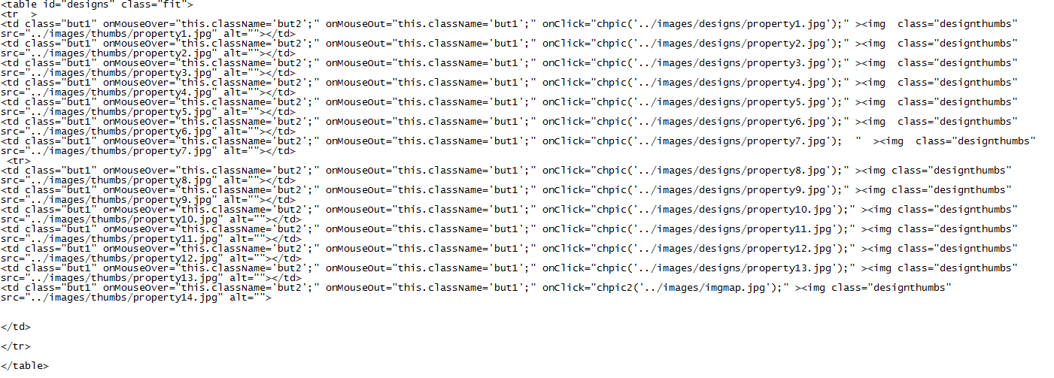

On the process and faq pages I used a script to hide and show text in divs. This script hides a body of text and when the user clicks the link it shows the hidden text.  
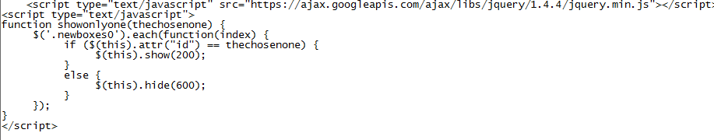

On the contact page I used a google map script. This script shows an address on google maps.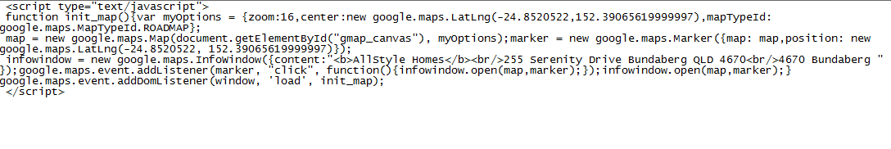

And on all pages I used a typewriter effect for header 3. This script adds a typewriter effect to the header 3 on all pages.

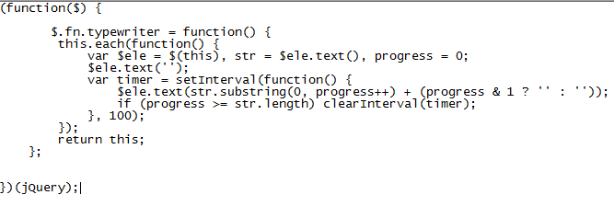

This is the code for mail.inc php file. This code inserts the first name last name and email into the database, removes first name last name and email from database and sends email.  
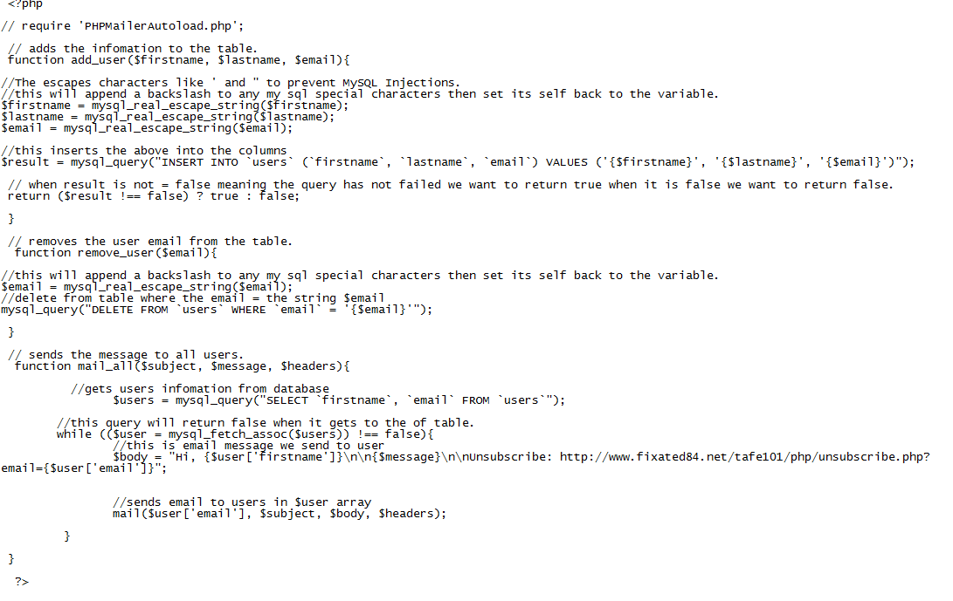

This is the code from maillist php. The page includes a password protect page to stop unwanted access to the admin page of the mailing list. The second bit of the code adds the information from the database and displays on the website. 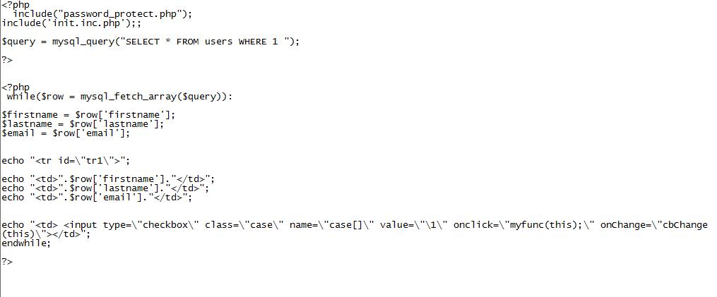

I tested the website and it works on pc on internet explorer, google chrome and Firefox and on mac os safari. Also tested the site on a galaxy s4 and iphone6.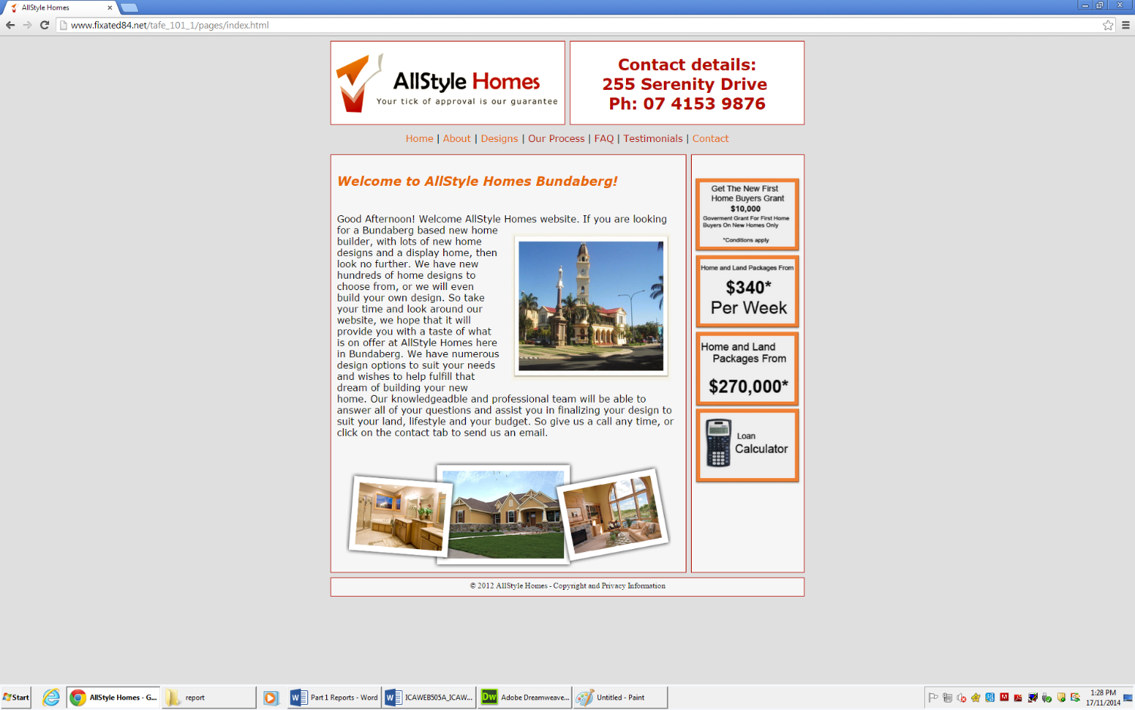  
  
Mobile site Layout Apple iPhone 6

 

Mobile Layout Samsung Galaxy S4  
 

The folder structure used is in the image below.  
